HAS IT A _________________ SHAPE?
ELLIPTICAL
OVATE
CORATE
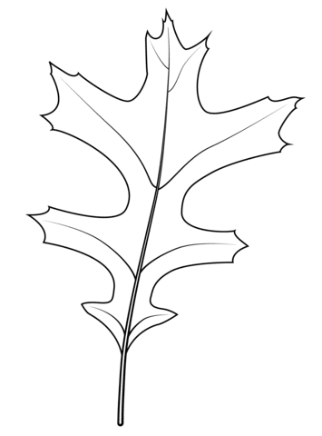
LANCEOLATE
PINNATIFID

YES, IT HAS NO, IT HAS NOT
HAS IT A _________________ MARGIN?
SERRATE
ENTIRE
DENTATE
LOBED

YES, IT HAS NO, IT HAS NOT
IS IT ______________ ?
RED
ORANGE
YELLOW
BROWN
GREEN

YES, IT IS NO, IT IS NOT

